File system Hierarchy
/ (forward slash) is the first and top-most directory in Linux.
It is called the Root Directory.
- Linux file system starts from / (root directory).
- All folders and files begin from /.
Example:
/
/home
/home/ujer
Path breakdown:
- / → Root directory
- home → Home folder
- ujer → User's folder
- Desktop → Desktop folder
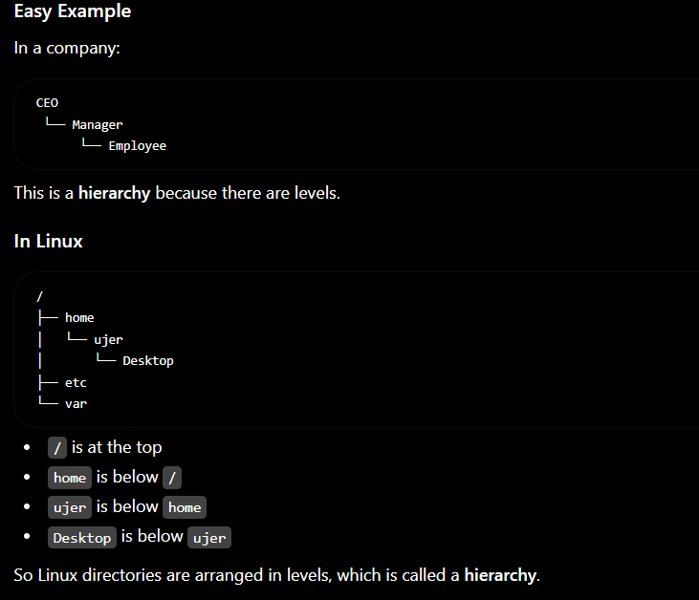
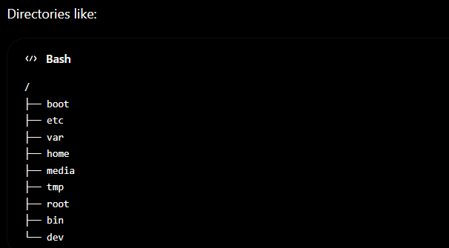
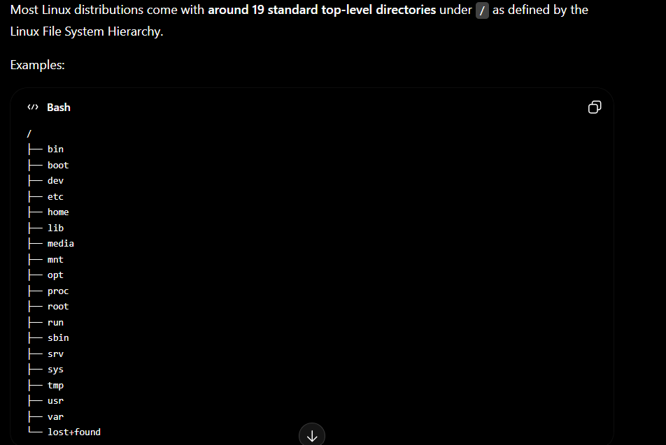

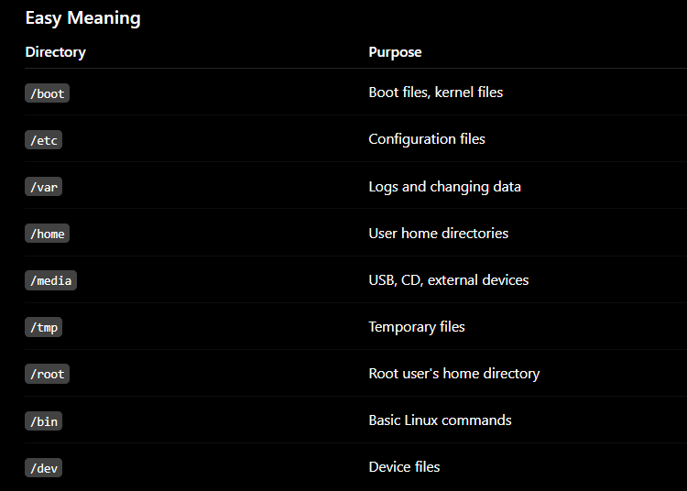
What is means by logs ?
Log means a record of events or activities.
Real Life Example
Your school attendance register is a log.
18 Jun - Present
19 Jun - Present
20 Jun - Absent
This is a record, so it's a log.

- /dev.
Your Linux SSD/HDD is represented inside /dev.

/media
usually used when you connect removable devices such as:
- USB Pen Drive
- External Hard Disk
- Memory Card
- CD/DVD
Example:
You plug in a USB drive.
Linux may automatically mount it at:
/media/ujer/USB
"When you plug in a USB, it appears in /media. You can see the USB data in /media and then copy files from /media to the Desktop or any other location."

/boot
stores the files required to start the Linux operating system."
Simple Example
Power ON
↓
/boot files are used
↓
Linux starts

/usr
Meaning: Stores installed software, commands, and applications.
Usually contains system software and Linux programs:
Example:
/usr/bin
/usr/sbin/nginx
/usr/bin/python3
/usr/bin/git
system software
nginx
apache
python
vim
git
mkdir
ls
Think:
👉 Most software you install is stored under /usr.

/lib
Meaning: Stores libraries (helper files) used by programs and commands.
Example:
ls
ls uses files from /lib to run.
Think:
👉 Like fuel needed for programs to work.
/lib does not store commands.
/lib stores library files that help commands and programs work.

/proc
Meaning: Contains information about running processes and the kernel.
Example:
/proc/cpuinfo
Shows CPU information.
Think:
👉 Live information about your system.
/proc contains information about the whole Linux system.
But technically, it contains live information about:
- CPU
- Memory
- Running processes
- Kernel
- System status

/sys
Meaning: Contains information about hardware and the Linux kernel.
Think:
👉 Linux talks to hardware through /sys.

/mnt
Meaning: Temporary mount point.
Example:
sudo mount /dev/sdb1 /mnt
Think:
👉 Temporary place to attach a disk.
Difference between media and mnt
/media
When you plug in a USB or external HDD, Linux usually mounts it automatically:
/media/ujer/USB
You normally don't choose the location.

/mnt
You choose the location yourself:
/mnt/photos
/mnt/games
/mnt/data
and mount the disk there.

/opt
Meaning: Optional software installed manually.
Example:
/opt/google
/opt/zoom
Think:
👉 Extra applications.

/run
Meaning: Stores temporary runtime information.
Example:
- Running services information
- Process IDs (PID)
Think:
👉 Information needed while Linux is currently running.

/sbin
Meaning: System administration commands.
Examples:
fdisk
reboot
shutdown
Think:
👉 Commands mainly used by root/admin.

/srv
Meaning: Data provided by services.
Example:
/srv/www
Think:
👉 Files used by servers (web server, FTP server, etc.).

/lost+found
Meaning: Stores recovered files after disk repair.
Think:
👉 Linux's "Lost and Found" box.

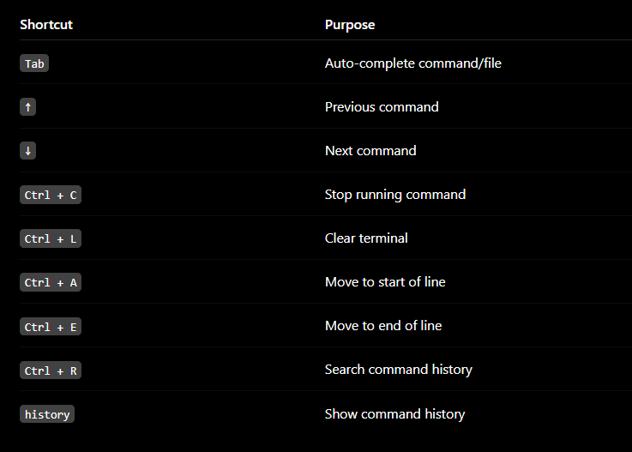

HOMEWORK
LEARN ALL DEFAULT DIRECTORIES DO

